In this video we will discuss, creating a view to insert a new employee into the database table **tblEmployee**. Please [watch Part 11](http://csharp-video-tutorials.blogspot.com/2013/05/part-11-using-business-objects-as-model.html), before proceeding with this video.

**We want to present the end user with a form as shown in the image below**   
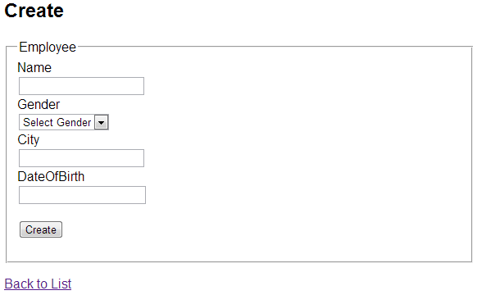  
  
Copy and paste the following **"Create"** action method, in **EmployeeController** class.   
[HttpGet]  
public ActionResult Create()  
{  
    return View();  
}  
  
Please note that, the method is decorated with **"HttpGet"** attribute. This makes this action method to respond only to the **"GET"** request.   
  
Now let's add a **"Create"** view. To do this, right click on the **"Create"** action method and select **"Add View"** from the context menu. Set  
**1.** View name = **"Create"**  
**2.** View engine = **"Razor"**  
**3.** Select **"Create Strongly-typed view"** checkbox  
**4.** Select **"Employee"** class, from **"Model class"** dropdownlist  
**5.** Scaffold Template = **Create**  
**6.** Click **"Add"** button  
  
At this point **"Create.cshtml"** view will be added in **"Employee"** folder. If you have the following **"Scripts"** section at the bottom of the view, please delete it. We will discuss about sections and scripts in a later video session.  
@section Scripts {  
    @Scripts.Render("~/bundles/jqueryval")  
}  
  
**Run the application and navigate to the following URL**  
"http://localhost/MVCDemo/Employee/Index"  
  
**Click on "Create New" link. You will be naviaged to the following URL**  
"http://localhost/MVCDemo/Employee/Create"  
  
A form with textboxes to add a new employee is rendered. For employee **"Gender"** it is ideal to have a dropdownlist instead of a text box. To achieve this, REPLACE THE FOLLOWING LINE  
@Html.EditorFor(model => model.Gender)  
  
WITH  
@Html.DropDownList("Gender", new List<SelectListItem>  
{  
new SelectListItem { Text = "Male", Value="Male" },  
new SelectListItem { Text = "Female", Value="Female" }  
}, "Select Gender")  
  
Run the application and notice that, a dropdownlist is now displayed for **"Gender"**.  
  
If you click on **"Create"** button, you will get an error message stating - The resource cannot be found. This is because we don't have the **"Create"** controller action method that can handle **HTTPPost** request. We will discuss, fixing this in our next video.